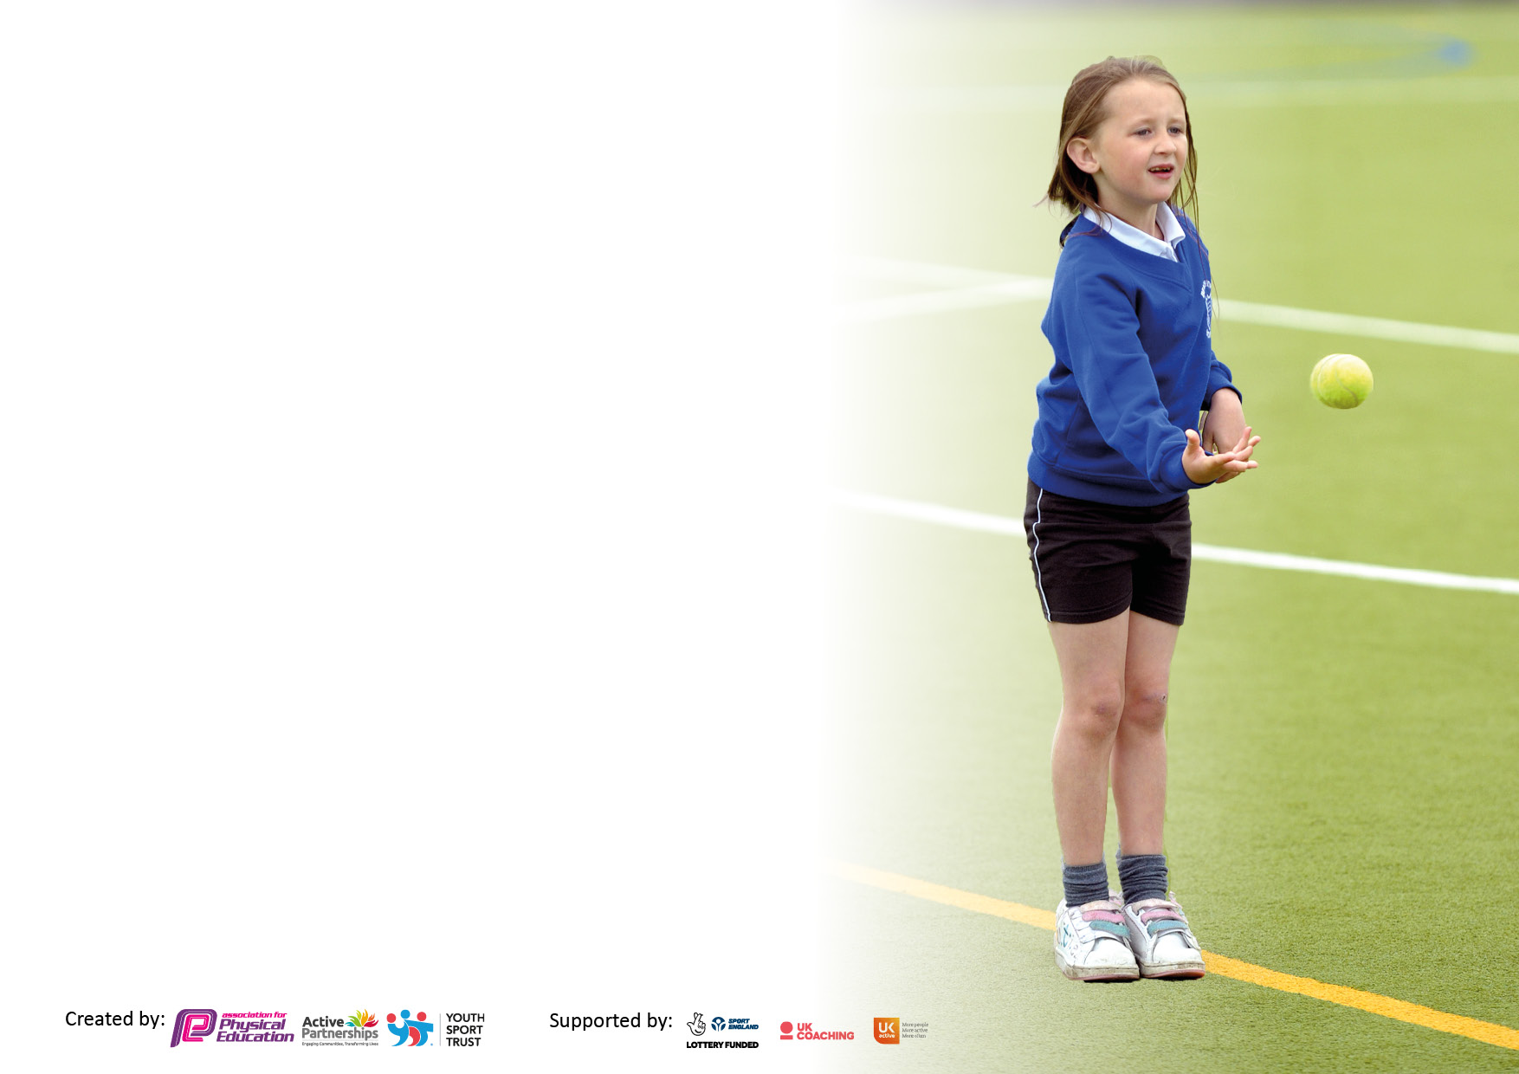

It is important that your grant is used effectively and based on school need. The Education Inspection Framework makes clear there will be a focus on **‘whether leaders and those responsible for governors all understand their respective roles and perform these in a way that enhances the effectiveness of the school’**.

Under the Quality of Education Ofsted inspectors consider:

**Intent** - Curriculum design, coverage and appropriateness

**Implementation** - Curriculum delivery, Teaching (pedagogy) and Assessment

**Impact** - Attainment and progress

To assist schools with common transferable language this template has been developed to utilise the same three headings which should make your plans easily transferable between working documents.

Schools must use the funding to make **additional and sustainable** improvements to the quality of Physical Education, School Sport and Physical Activity (PESSPA) they offer. This means that you should use the Primary PE and sport premium to:

* Develop or add to the PESSPA activities that your school already offer
* Build capacity and capability within the school to ensure that improvements made now will benefit pupils joining the school in future years
* The Primary PE and sport premium should not be used to fund capital spend projects; the school’s budget should fund these.

Pleasevisitgov.ukfortherevisedDfEguidanceincludingthe5keyindicatorsacrosswhichschoolsshoulddemonstrate animprovement.Thisdocumentwillhelpyoutoreviewyourprovisionandtoreportyourspend.DfEencouragesschools to use this template as an effective way of meeting the reporting requirements of the Primary PE and Sport Premium.

We recommend you start by reflecting on the impact of current provision and reviewing the previous spend.

Schools are required to publish details of how they spend this funding, including any under-spend from 2021/2022, as well as on the impact it has on pupils’ PE and sport participation and attainment. **All funding must be spent by 31st July 2023.**

We recommend regularly updating the table and publishing it on your website throughout the year. This evidences your ongoing self-evaluation of how you are using the funding to secure maximum, sustainable impact. Final copy must be posted on your website by the end of the academic year and no later than the 31st July 2023. To see an example of how to complete the table please click HERE.

**Details with regard to funding**

Please complete the table below.

|  |  |
| --- | --- |
| Total amount carried over from 2021/22 | £0 |
| Total amount allocated for 2021/22 | £20,333 |
| How much (if any) do you intend to carry over from this total fund into 2022/23? | £0 |
| Total amount allocated for 2022/23 | £19,260 |
| Total amount of funding for 2023/23. To be spent and reported on by 31st July 2023. | £ 18,684 |

**Swimming Data**

Please report on your Swimming Data below.

|  |  |
| --- | --- |
| Meeting national curriculum requirements for swimming and water safety.  N.B. Complete this section to your best ability. For example you might have practised safe self-rescue techniques on dry land which you can then transfer to the pool when school swimming restarts.  **Due to exceptional circumstances priority should be given to ensuring that pupils can perform safe self rescue even if they do not fully meet the first two requirements of the NC programme of study** |  |
| What percentage of your current Year 6 cohort swim competently, confidently and proficiently over a distance of at least 25 metres?  **N.B.** Even though your pupils may swim in another year please report on their attainment on leaving primary school at the end of the summer term 2022.  Please see note above | 79% of 55 children |
| What percentage of your current Year 6 cohort use a range of strokes effectively [for example, front crawl, backstroke and breaststroke]?  Please see note above | 64% |
| **What percentage of your current Year 6 cohort perform safe self-rescue in different water-based situations?** | 75% |
| Schools can choose to use the Primary PE and sport premium to provide additional provision for swimming but this must be for activity **over and above** the national curriculum requirements. Have you used it in this way? | Yes/No |

**Action Plan and Budget Tracking**

Capture your intended annual spend against the 5 key indicators. Clarify the success criteria and evidence of impact that you intend to measure to evaluate for pupils today and for the future.

|  |  |  |  |  |
| --- | --- | --- | --- | --- |
| **Academic Year:** 2022/23 | **Total fund allocated: £19,260** | **Date Updated: 26.6.2023** | |  |
| **Key indicator 1:** The engagement of all pupils in regular physical activity – Chief Medical Officers guidelines recommend that primary school pupils undertake at least 30 minutes of physical activity a day in school | | | | Percentage of total allocation: |
| 4% |
| **Intent** | **Implementation** | | **Impact** |  |
| Your school focus should be clear what you want the pupils to know and be able to do and about  what they need to learn and to  consolidate through practice: | Make sure your actions to achieve are linked to your intentions: | Funding allocated: | Evidence of impact: what do pupils now know and what can they now do? What has changed?: | Sustainability and suggested next steps: |
| Marking for daily mile checked for clarity and safety. | All children to participate in at least 30 minutes of physical activity per day. | £0 | Markings are permanent. Marking to be checked yearly for signs of wear and tear. | Continue to check markings. Areas to be resprayed when needed. |
| Sports coaches/adult employed to deliver sports activities during lunchtime. | Pupil premium, disadvantaged and SEND (and other targeted children) to participate. | See key indicator 3 | Children given opportunity to engage in a wider range of sporting activities with a focus on fun, teamwork and engagement. | Children to suggest further games/sports they would like during lunchtimes. Introduction of sports leaders to help run sessions. |
| Building of outdoor shelving/boxes so that equipment is always readily available to the children at every break time. | All children have opportunities during break time to stay active and enjoy being active. | £100 | Children do not need to rely on adults to provide equipment. Equipment is readily available for use now. | Check on boxes frequently to ensure withholding proper use. |
| Outdoor gymnastics equipment and trim trail checked for safety. | All children to have the opportunity to practice a range of activities while outside during breaks. Also for use during Fit in 15 and PE lessons. | £0 | To be checked yearly for signs of wear. |  |
| Purchase of new play time equipment to engage children in free choice of physical activity | Children to have free choice and easy access to a range of equipment to stimulate active play | £620 | Pupils more active as choosing to play with new equipment | Checked frequently to ensure still suitable for use. |
| **Key indicator 2:** The profile of PESSPA being raised across the school as a tool for whole school improvement | | | | Percentage of total allocation: |
| 9% |
| **Intent** | **Implementation** | | **Impact** |  |
| Your school focus should be clear what you want the pupils to know and be able to do and about  what they need to learn and to  consolidate through practice: | Make sure your actions to achieve are linked to your intentions: | Funding allocated: | Evidence of impact: what do pupils now know and what can they now do? What has changed?: | Sustainability and suggested next steps: |
| Sports coach/ adult to lead a range of activities during lunch time to encourage participation, fun and teamwork | More children active during lunchtime with a focus on girls, PP and other targeted groups. | See key indicator 3 | Pupils able to participate in a range of structured games | Development of teamwork and sporting attitude to continue. Children to have an active role in suggesting games they would like to play. |
| Application for The school games mark made. | Activity and participation levels in a range of sports high enough to achieve gold standard. | £0 |  | Application to be made again during the next academic year. Gold to be aimed for. |
| New equipment purchased for delivery of PE lessons. | Improvement of delivery of PE lessons due to the teachers and children having access to a wider range/newer resources. | £533 | Teacher to have the correct equipment to teach skills appropriately leading to the development of skills of more children throughout the school. | Old/unsuitable resources discarded and new resources utilized. |
| Imoves subscription renewed to and upgraded to allow all staff to access PE lessons, active and mindfulness resources. | Children and staff to access visual resources for PE lessons including dance. Access to active lessons across all subject areas. | £997 |  | Renewal for subscription planned for foreseeable future |
| Sports Day Stickers for use as rewards for all children. | Children to be rewarded instantly for their efforts during sports day events. | £12 | Children motivated to compete. |  |
| Football affiliation fees for cup and league games. | Insurance to cover competitors during matches. | £100 | All children insured during games. | Continued next year. |

|  |  |  |  |  |
| --- | --- | --- | --- | --- |
| **Key indicator 3:** Increased confidence, knowledge and skills of all staff in teaching PE and sport | | | | Percentage of total allocation: |
| 56% |
| **Intent** | **Implementation** | | **Impact** |  |
| Your school focus should be clear | Make sure your actions to | Funding | Evidence of impact: what do | Sustainability and suggested |
| what you want the pupils to know | achieve are linked to your | allocated: | pupils now know and what | next steps: |
| and be able to do and about | intentions: |  | can they now do? What has |  |
| what they need to learn and to |  |  | changed?: |  |
| consolidate through practice: |  |  |  |  |
| Imoves subscription renewed to and upgraded to allow all staff to access PE lessons, active and mindfulness resources. | Children and staff to access visual resources for PE lessons including dance. Access to active lessons across all subject areas. | See key indicator 2 | Imoves subscription renewed to and upgraded to allow all staff to access PE lessons, active and mindfulness resources. | Children and staff to access visual resources for PE lessons including dance. Access to active lessons across all subject areas. |
| New equipment purchased for delivery of PE lessons. |  | See key indicator 2 | New equipment purchased for delivery of PE lessons. |  |
| Sports coach brought in to deliver gymnastics unit for half term in each year group for staff CPD. | Staff feel more confident with the delivery of gymnastics within curriculum lessons | £4578 | Staff have increased knowledge of gymnastics and are more confident in teaching it. | Questionnaire on staff CPD now required. Gymnastics already built into every year groups curriculum coverage. |
| Lead Adult support offered to ensure skilled staff who feel confident and supported and well prepared for the teaching of PE lessons and active breaks. | Ensure all staff are confident in teaching lessons and leading active times throughout the school day. | £6127 | Staff feel supported and know where to go for support. Equipment well maintained and always ready for lesson use, reducing time in lessons wasted |  |
| **Key indicator 4:** Broader experience of a range of sports and activities offered to all pupils | | | | Percentage of total allocation: |
| 22% |
| **Intent** | **Implementation** | | **Impact** |  |
| Your school focus should be clear | Make sure your actions to | Funding | Evidence of impact: what do | Sustainability and suggested |
| what you want the pupils to know | achieve are linked to your | allocated: | pupils now know and what | next steps: |
| and be able to do and about | intentions: |  | can they now do? What has |  |
| what they need to learn and to |  |  | changed?: |  |
| consolidate through practice: |  |  |  |  |
| After school clubs provided every day of the week by specialist coaches so all children have the opportunity to participate in a club | Clubs available from Years 1 - 6 | £2667 | Children have learnt a range of new skills which they can now apply to a range of sports, both after school and within PE lessons. | Continue to offer clubs for all children. |
| Tennis sessions at Waterloo Tennis club | Children get to experience playing tennis on real courts and have a chance to increase their confidence within different sports | £1600 | Children feel confident with tennis and enjoy playing. Many have signed up to after school/ weekend club at the club. | Continue next year. |

|  |  |  |  |  |
| --- | --- | --- | --- | --- |
| **Key indicator 5:** Increased participation in competitive sport | | | | Percentage of total allocation: |
| 7% |
| **Intent** | **Implementation** | | **Impact** |  |
| Your school focus should be clear | Make sure your actions to | Funding | Evidence of impact: what do | Sustainability and suggested |
| what you want the pupils to know | achieve are linked to your | allocated: | pupils now know and what | next steps: |
| and be able to do and about | intentions: |  | can they now do? What has |  |
| what they need to learn and to |  |  | changed?: |  |
| consolidate through practice: |  |  |  |  |
| Subscription to Chesterfield High School Inter sports competition scheme, which provides competitions for all year groups from Yr1-6. | Children from Y1 to Y6 compete in inter school sports activities. | £350 | Children able to compete in a range of sporting activities with other local schools. Raised the profile of school teams. Encouraged children to compete. | Subscription to be renewed next year to allow further experience of inter school competitions. |
| Sports coach (and release for Adult) to take Children from Yr1-6 (including ASD children) to competitive sports event following the SSCo games calendar. | Develop squads targeted at sports for intra and inter school competitions. | See key indicator 3 | Pupils able to attend competitions and proper the school teams. | Development of competitive skills of children to be promoted throughout the school. |
| Purchase of additional sports equipment to allow for a broader range of sport competitions during intra-school competitions | Children given the opportunity to explore a wide range of sports, including boccia and curling | £1000 | Children know of a wide range of sports and have some skills in how to play. |  |

|  |  |
| --- | --- |
| Signed off by | |
| Head Teacher: |  |
| Date: | 26.6.23 |
| Subject Leader: | Alexandra Robertshaw |
| Date: | 26.6.23 |
| Governor: |  |
| Date: |  |