

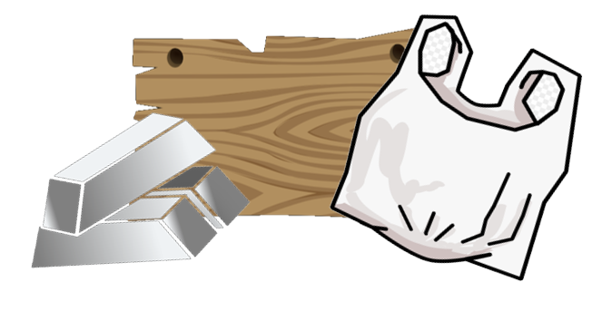

* The names of some everyday materials
* That objects are made from different materials (a ruler can be plastic)
* Different materials are suitable for different purposes (windows are glass because it is see-through and waterproof)

I will be able to:

* Sort materials into categories based on their properties
* Decide on the suitability of materials for particular purposes
* Predict what will happen when tests are carried out on materials

**Seasons:**

* The UK has 4 seasons (autumn, winter, spring and summer)
* In the summer, the weather is typically warm and sunny and the days are longer.
* In the autumn, it begins to get colder. Leaves fall from some trees and the days begin to get shorter.
* I will be able to talk about and describe the weather.

Categorise- place in a particular group.

Predict- guess what may happen in the future.

Fair test- a test which controls all but one variable.

Property- a characteristic of something.

Suitability- something being right for a particular purpose.

Material – what something is made out of

Object – a thing (a ruler, a teddy…)

* Wood
* Plastic
* Glass
* Metal
* Water
* Soft
* Stiff
* Flexible/bendy
* See through/transparent
* Shiny

Seasons: autumn, winter, spring, summer

Vocabulary

I can name some everyday materials

In the past, toys were often made of wood and metal.

Waterloo Primary School – Spring Science Knowledge Organiser

What will I know by the end of this unit of work?

Year: 1

Topic: Materials

What should I already know?