

I can name some basic parts of the body.

I can name some common animals.

I have discussed carnivores, omnivores and herbivores.

In the UK, we have 4 seasons.

Each season has typical weather.

Vocabulary

Mammals – mammals have hair or fur. They give birth to live young. Mammals produce milk for their babies.

Fish – fish live in water. They have fins, scales and gills.

Reptiles – Reptiles have dry, scaly skin. They lay eggs on land.

Amphibians – Amphibians live on land or in water. They lay eggs in water.

Birds – Birds have 2 legs, wings and feathers. They have a beak or bill and hatch from eggs.

Carnivores- animals that eat meat.

Herbivores- animals that eat plants.

Omnivores- animals that eat meat and plants.

Categorise- place in a particular group.

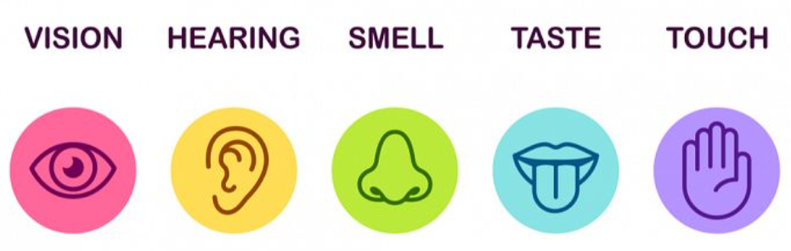

Seasons: autumn, winter, spring, summer

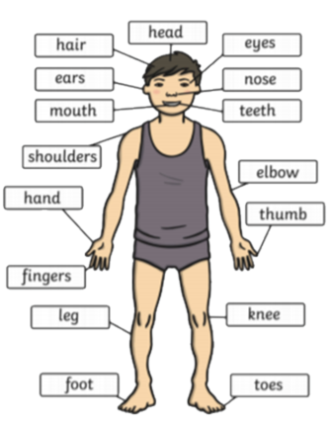

* Parts of the human body
* Which body part is associated with which sense
* A variety of common animals
* Some animals which are carnivores, herbivores and omnivores.

**Seasons:**

In the winter, the weather is typically cold (rain, snow, hail, wind) and the days are shorter.

In the spring, it begins to get warmer. New plants begin to grow and flower.

I will be able to talk about and describe the weather.

Waterloo Primary School – Autumn Science Knowledge Organiser

What will I know by the end of this unit of work?

Year: 1

Topic: Animals including humans.

What should I already know?