Vocabulary
- Animals, including humans, have offspring which grow into adults.
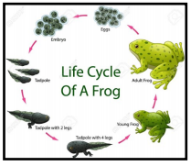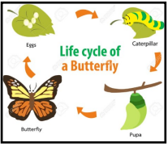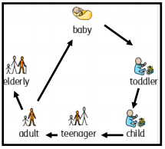
- Animals, including humans, have offspring which grow into adults
- All animals, including humans have basic needs
- To keep physically healthy, we need a healthy diet and regular exercise. We have to keep ourselves clean
- It is also important to look after our mental health
- When I exercise I feel different
I will be able to:
- Ask simple questions and recognise that they can be answered in different ways
- Make careful observations and use them to suggest answers
- Gather, record and present information
What will I know by the end of this unit of work?
Year: 2
- There are five types of vertebrates (mammals, fish, reptiles, amphibians, birds).
- Vertebrates are animals that have a backbone.
- Some animals give birth to live young but others lay eggs.
What should I already know?
Topic: Animals including humans
Waterloo Primary School – Science Knowledge Organiser
Life Cycle – changes that happen from birth until death
Disease – illness
Personal hygiene – keeping yourself clean
Medicines – treatments for illness or pain
Muscle- tissue in the body that enables movement
Survive – continue to exist
Skeleton – framework of bones in your body
Pictogram – simple images that represent something
Offspring – an animal’s young
Bar chart – a chart which uses bars to show and compare amounts
Backbone – column of small bones in your back

