• Plants require things such as water, warmth, nutrients from soil and light to grow

• If they do not have one or more of these things, they may stop growing.

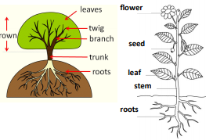

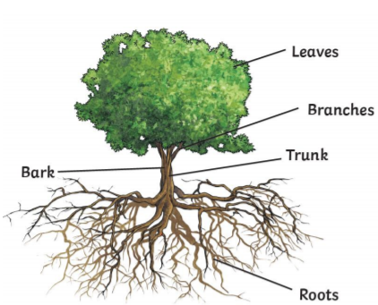

I will be able to:

* Plant seeds and observe how plants need water, light and a suitable temperature to grow and stay healthy.
* Ask simple questions and use my observations to answer questions
* Perform simple tests

Branch – parts of a plant which have leaves, fruit

Wild – not looked after by humans

Weed – an unwanted plant

Vegetation – plants, trees and flowers

Bulb – a root shaped like an onion that grows into a plant

Seed – part of a flowering plant that can grow into a new plant

Stem – upright part of a plant

Trunk – upright part of a tree

Tree – a tall plant with a hard trunk

Crop – plants grown in large quantities for food

Fruits and Vegetables – parts of plants which can be eaten

Roots – parts of plants that grown under ground

Reproduce – when an animal or plant produces a new animal or plant

Petal – colourful part of a flower

Nutrients – substances which help plants to grow

Leaf/leaves – part of a plant which helps it to produce food (often green and thin)

Vocabulary

What will I know by the end of this unit of work?

The names of some common plants

* Deciduous trees lose their leaves in the autumn every year
* Evergreen trees have green leaves all year round
* The parts of a plant including petals, fruits, roots, bulbs, seeds, stem, trunks and branches.

What should I already know?

Year: 2

Topic: Plants

Waterloo Primary School – Science Knowledge Organiser