
Absorb | soak up or take in
Fossils | remains or impression of a prehistoric plant or animal embedded in rock and preserved in petrified form
Nutrients  Organic | substances that help plants and animals to grow  matter derived from organisms, especially decayed matter in soil
Palaeontology | the study of fossils as a guide to the history of life on Earth
Permeable | if a substance is permeable, something such as water or gas can pass through it or soak into it
Properties | the qualities or features that belong to something and make it recognisable
Rock | a solid mass made up of minerals. Rock forms much of the earth's outer layer, including cliffs and mountains
soil | the substance on the surface of the earth in which plants grow

Vocabulary
- Soil contains nutrients
- That materials can be absorbent and that plant roots absorb nutrients and water from the soil
- That some materials are used for certain purposes because of their properties

Investigate
- Explore the types of rocks you can find in the local environment.
- Explain why rocks are used for different purposes, based on their properties.
- Research the different living things whose fossils are found.
- Explore the different kinds of soils.
- Investigate what happens when rocks are rubbed together.
- Investigate what happens to rocks when they are in water.

There are three types of rocks that are formed naturally.
• Igneous:
• When molten magma cools, igneous rocks are formed.
• This either cools and forms rocks under the earth’s surface, or flows out of erupting volcanoes as lava and may mix with other minerals.
• Examples include granite and bas-alt.

• Sedimentary:
• Sometimes, little pieces of rocks that have been weathered can be found at the bottom of lakes, seas and rivers This is called sediment.
• Over millions of years, layers of this sediment builds up forming sedimentary rocks.
• Examples include limestone and chalk.
• Sedimentary rocks are porous and can easily be worn down.

• Metamorphic:
• When some igneous and sedimentary rocks are heated and squeezed (pressured), they form metamorphic rocks.
• Examples include slate and marble.
• Metamorphic rocks are strong.

Chalk, clay, granite, marble, sandstone, marble and slate are all types of rock.

Fossils are the remains of prehistoric life.
• They are usually formed when a living thing (plant or animal) dies and the body is covered up or buried by sediment over tens of thousands of years.

Soil is made from pieces of rock, minerals, decaying plants and water.
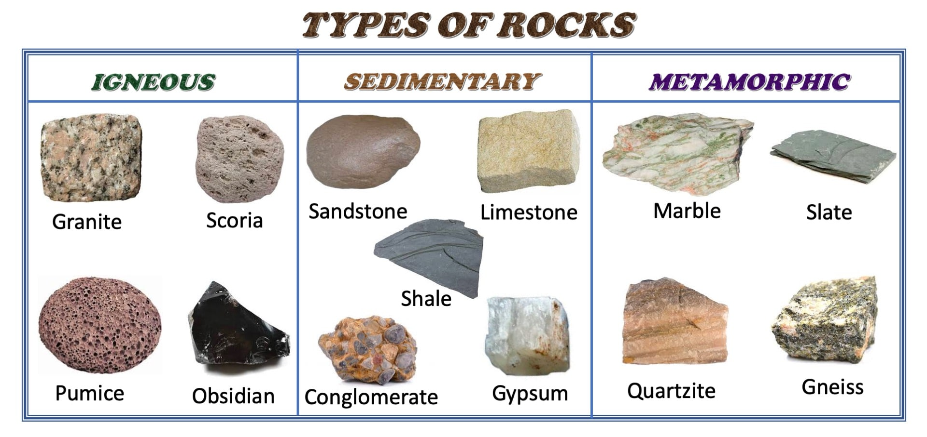

What will I know by the end of this unit of work?
Waterloo Primary School – Science Knowledge Organiser
Strand: Chemistry
What should I already know?
Year: 3
Topic: Rocks

