

• The parts of the human body and what they do, including our senses  
 • There are five types of vertebrates (mammals, fish, reptiles, amphibians, birds)   
• Vertebrates are animals that have a backbone and invertebrates are animals that do not have a backbone.  
• All animals need water, air and food to survive.

• How humans can be healthy.

What should I already know?

**Backbone/spine** - the column of small linked bones down the middle of your back  
**Bones** - the hard parts inside your body which form your skeleton   
**Endoskeleton -** the internal skeleton of an animal, especially the bony skeleton of vertebrates   
**Exoskeleton** - the protective or supporting structure covering the outside of the body of many animals   
**Joints -** the junction between two or more bones   
**Muscles -** something inside your body which connects two bones and which you use when you make a movement   
**Protection** - protecting someone or something means to prevent them from being harmed or damaged   
**Skeleton -** the framework of bones in your body  
**Skull** - a bone framework enclosing the brain of a vertebrate; the skeleton of a person's or animal's head  
**Support** - to hold something up   
**Tendons -** a strong cord in a person's or animal's body which joins a muscle to a bone   
**Vertebrate -** a creature which has a spine  
**Nutrition** - the process of providing or obtaining the food necessary for health and growth  
**Balanced diet** - a diet consisting of a variety of different types of food

Vocabulary

* Match animals to their skeletons
* Explore what would happen if humans did not have skeleton
* Identify which bones are used for support, protection and for movement
* Investigate how muscles contract and relax

Investigate

Vertebrates are animals that have a backbone. These skeletons are called endoskeletons - this means that the skeletons are on the inside of the bodies. 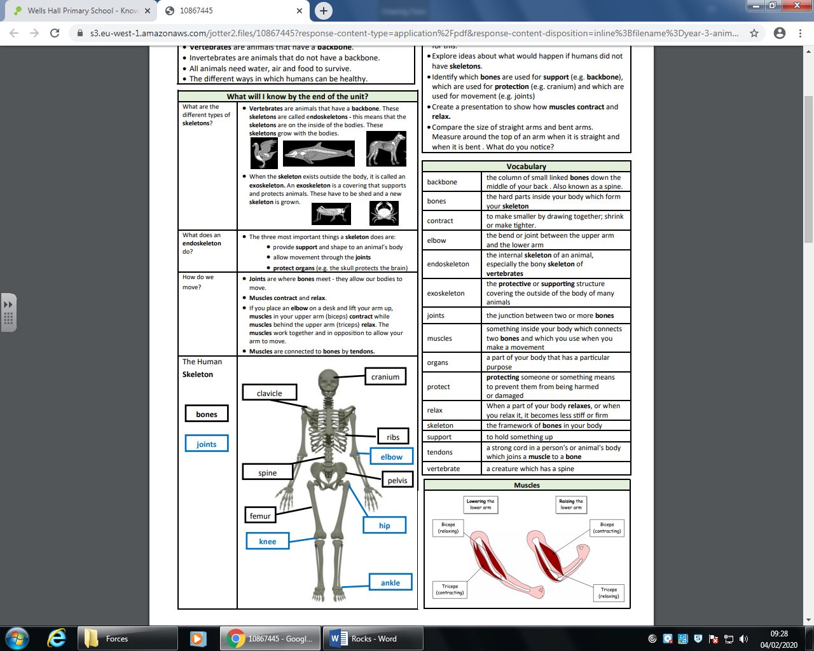

An exoskeleton is on the outside of a body. It is a covering that supports and protects animals. 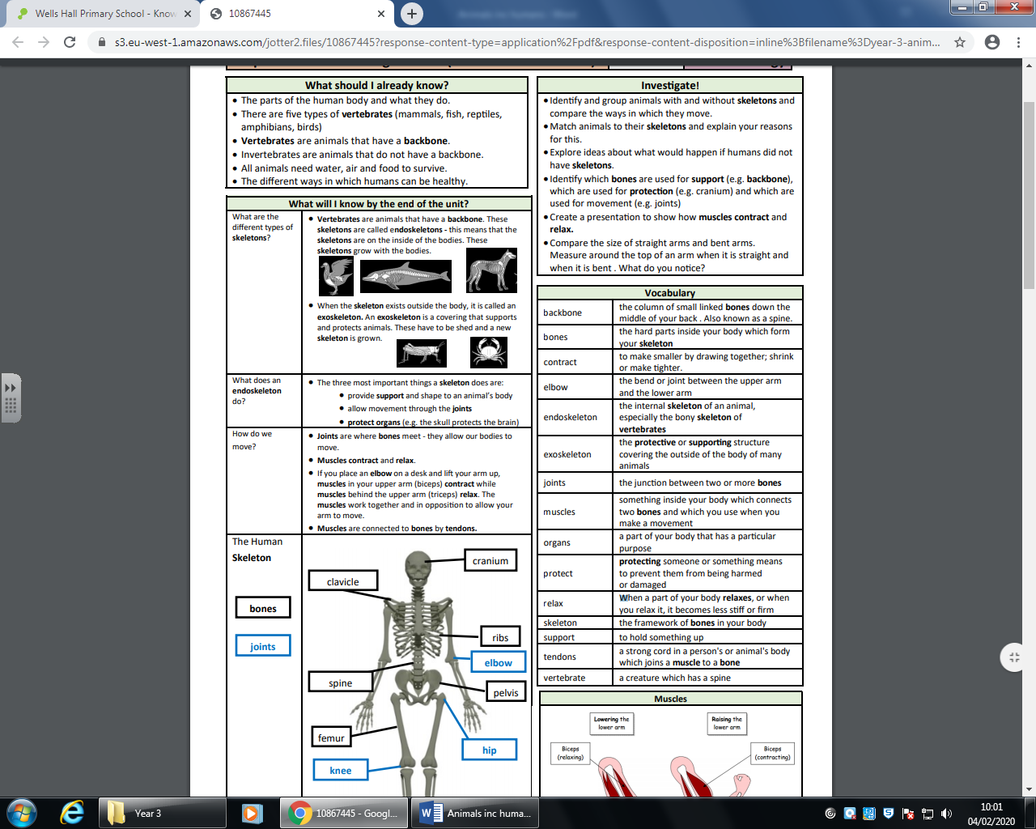

Skeletons: support, allow movement and protect organs (e.g. the skull protects the brain)

Joints are where bones meet - they allow our bodies to move. Muscles contract and relax. The muscles work together and in opposition to allow your arm to move. Muscles are connected to bones by tendons.

Animals, including humans get energy and nutients from what they eat.

To remain healthy and well we need a balanced diet.

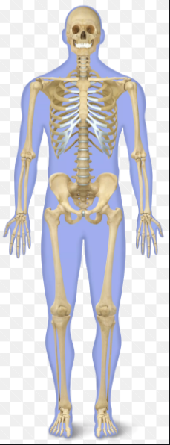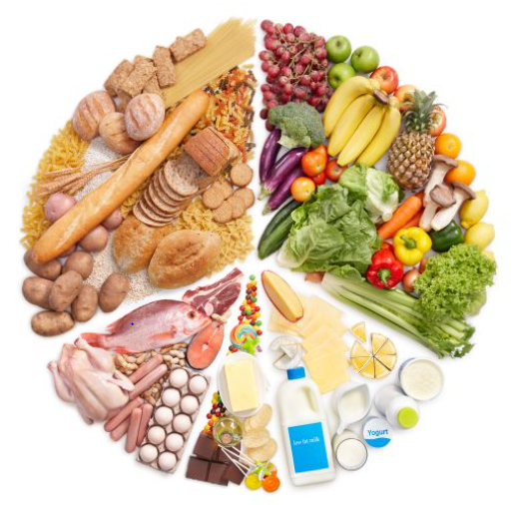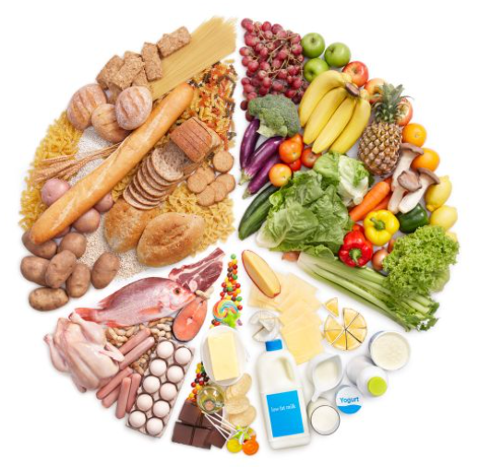

Topic: Animals including humans

Year: 3

What will I know by the end of this unit of work?

Waterloo Primary School – Science Knowledge Organiser

Strand: Biology