

**Block** – stops something coming through

**Darkness** - the absence of light

**Direction** – the route someone or something takes

**Light** - natural agent that stimulates sight and makes things visible

**Light source** – where light comes from

**Mirror** - a flat piece of glass which reflects light, so that when you look at it you can see yourself reflected in it

**Torch** - a small electric light which is powered by batteries and which you can carry

**Opaque** - if an object or substance is opaque, you cannot see through it

**Reflect** - sent back from the surface and not pass through it

**Shadow** - a dark shape on a surface that is made when something stands between a light and the surface

**Translucent** - if a material is translucent, some light can pass through it

**Transparent** - f an object or substance is transparent, you can see through it

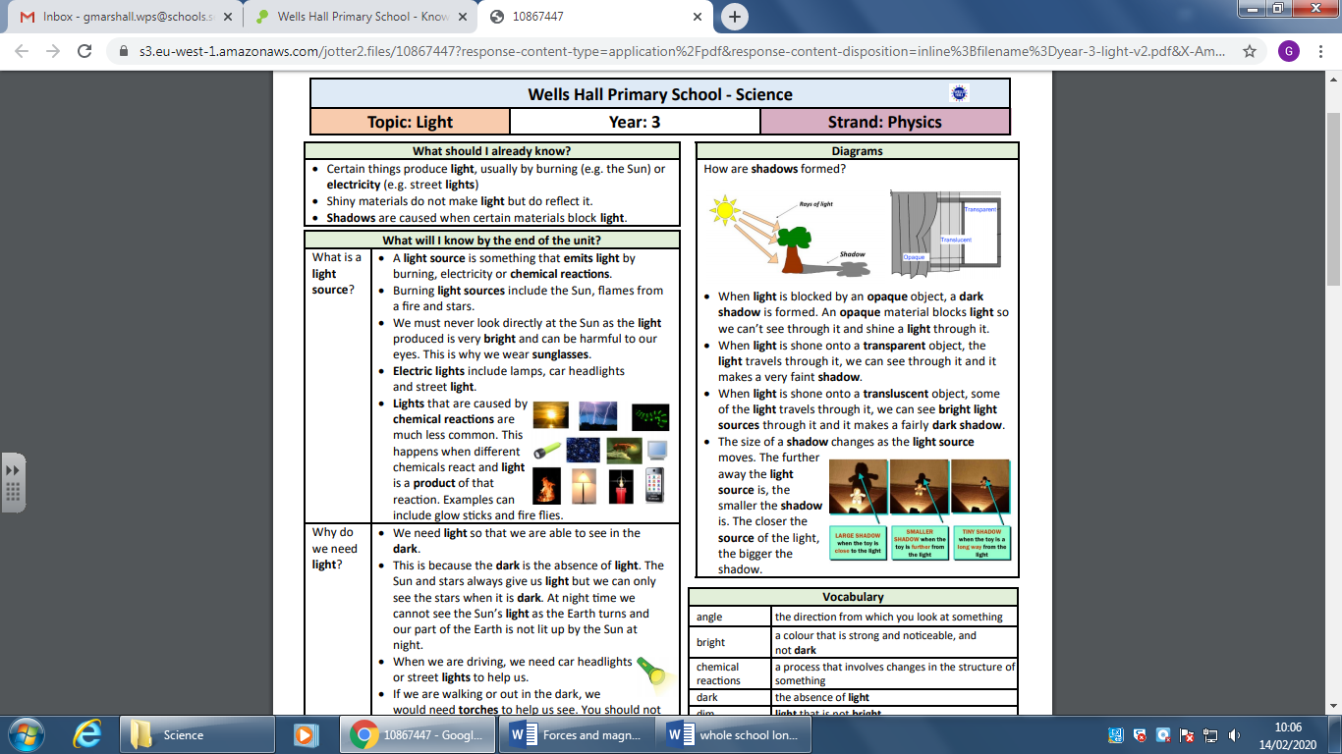

Vocabulary

* Natural light comes from the sun
* Plants need light to grow

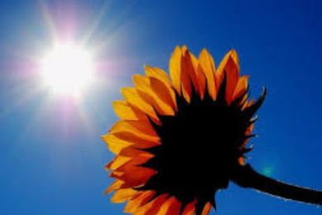

* A light source is something that gives light by burning, electricity or chemical reactions.
* Burning light sources include the Sun, flames from a fire and stars.
* We must never look directly at the Sun as the light produced is very bright and can be harmful to our eyes.
* We need light so that we are able to see in the dark.
* At night time we cannot see the Sun’s light as the Earth turns and our part of the Earth is not lit up by the Sun at night.
* When we are driving, we need car headlights and street lights to help us.
* If we are walking or out in the dark, we would need torches to help us see and reflective clothes so that drivers can see us.
* Light travels in straight lines. When light is blocked by an opaque object, a dark shadow is formed
* The Moon is not a source of light even though we can see it in the dark.

Investigate

• Why do lights seem brighter in the dark?   
• Explore which objects form shadows when light is shone on them.   
• How can you change the size and shape of shadows by using the same object?   
• What happens when light is reflected from different surfaces? What happens when light is reflected from a mirror? What happens when the angle of the mirror (or light source changes?)

Topic: Light

What will I know by the end of this unit of work?

Year: 3

Waterloo Primary School – Science Knowledge Organiser

Strand: Physics

What should I already know?