

**Air -** the invisible gaseous substance surrounding the earth, a mixture mainly of oxygen and nitrogen  
**Function –** something’s job   
**Leaves -** a flattened structure of a higher plant, typically green and blade-like, that is attached to a stem directly or via a stalk  
**Nutrients -** a substance that provides nourishment essential for the maintenance of life and for growth  
**Pollination -** the transfer of pollen to a stigma, ovule, flower, or plant to allow fertilisation  
**Seed formation –** the process of reproduction in plants  
**Seed dispersal -** the **movement, spread or transport of seeds away from the parent plant**  
**Transportation - transporting water, minerals and food** to all parts of the plant body

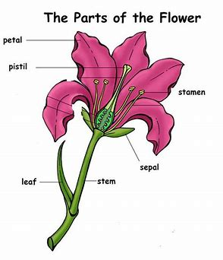

Vocabulary

* Things are living and which are not.
* A variety of common wild and garden plants, including deciduous and evergreen trees
* The structure of common flowering plants, including trees
* Seeds and bulbs grow into plants
* Plants need water, light and a suitable temperature to grow and stay healthy.
* Petals are usually bright - to attract insects so that they can collect pollen to make seeds. The seeds are then able to grow to make new plants.
* Leaves use carbon dioxide and sunlight to make food for the plant.
* The stem carries water and other nutrients from the roots to the rest of the plant. The stem also helps to keep the plant upright.
* The roots help to ‘anchor’ the plant in the soil. They also absorb water and nutrients from the soil.
* Plants need air, water, sunlight, nutrients, room to grow and suitable temperature. The amount of each of these may vary depending on the type of plant.
* The flowers create seeds

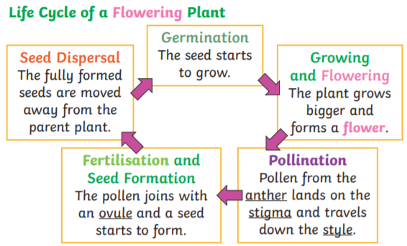

Investigate

• Compare the effect of different factors in plant growth (e.g. the amount of water and the amount of light).   
• Place white carnations in dyed water to observe how plants transport water.  
• Discover how seeds are formed by observing plant life cycles.   
• Dissect fruits/flowers to observe their structure and use this to explain how seeds are dispersed and how fertilisation occurs.

Waterloo Primary School – Science Knowledge Organiser

What should I already know?

Topic: Plants

What will I know by the end of this unit of work?

Year: 3

Strand: Biology