

Year: 4

Strand: Physics

Topic: Electricity

Waterloo Primary School – Science Knowledge Organiser

* Appliances in our classroom include: computer, monitor, interactive board, IPads and lights
* Some renewable and non-renwable sources
* How to keep safe when using electricity
* How to construct a simple circuit
* Some materials conduct electricity. Metals are good conductors. Some materials are insulators, such as wood and plastic.

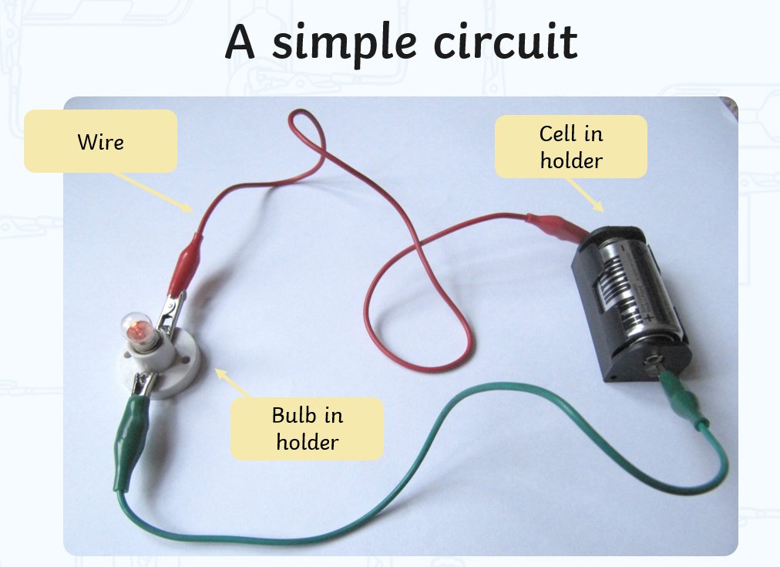

* For the bulb to light, the circuit must be a complete loop. A open switch will stop the circuit from being complete.

Investigate

* Safely set up equipment to investigate circuits
* Make careful observations
* Gathering and record data
* recording findings using simple scientific language, drawings, labelled diagrams and tables

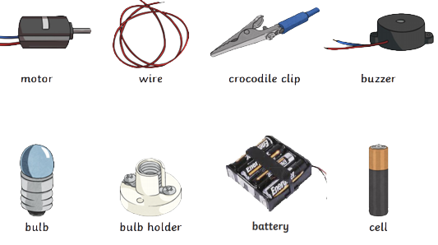

Conductors: A material that allows the flow of electricity

Insulators: A material that does not allow the flow of electricity

Electrical appliance: a piece of equipment that is powered byelectricity

Mains Electricity: electricity that powers appliances which are plugged in rather than battery operated.

Vocabulary

* Electricity can be dangerous
* I use electricity at home, in school and out in the community
* Different materials have different properties which make them fit for different purposes

What will I know by the end of this unit of work?

What should I already know?