

Topic: Sound

Strand: Physics Year 4

Waterloo Primary School – Science Knowledge Organiser

Year: 4

* Sounds can be made in different ways (instruments and body parts)
* Sounds can be loud and quiet and high and low
* I use my ears to hear sounds

What will I know by the end of this unit of work?

What should I already know?

* Set up practical investigations
* Make careful observations and, take accurate measurements using standard units, using data loggers
* Recording findings using simple scientific language, drawings and labelled diagrams

Investigate

* We can make sounds in different ways: hit, pluck, blow, scrape.
* Sounds are made when something vibrates.
* Sound travel in sound waves. Sounds can travel through solids, liquids and gases.

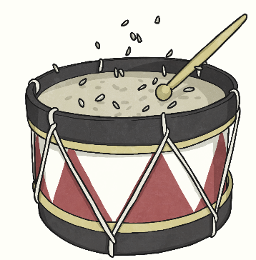

* When we hit, pluck, blow or scrape harder, the vibrations are bigger (amplitude) and we make a louder sound.
* When we hit, pluck, blow or scrape more gently, the vibrations are smaller (amplitude) and we make a quieter sound.

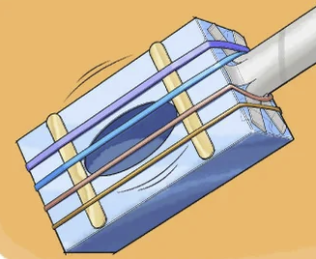

* The faster an object vibrates, the higher the pitch.
* The slower something vibrates, the lower the pitch.
* The further we move from the source of a sound, the fainter it becomes.

Vibrate – moving continuously to and fro

Volume – loud or quiet

Pitch – high or low

Sound waves – sound travels in sound waves

Ear drum – our ear drum vibrates

Amplitude – the size of vibrations

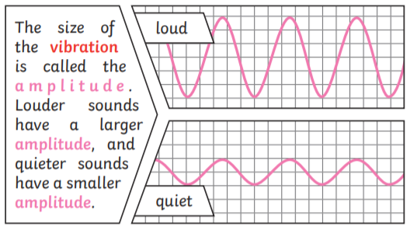

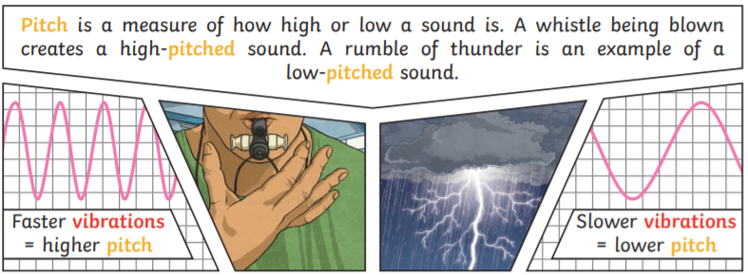

Vocabulary