

Year: 4

Strand: Biology

Topic: Living Things and Their Habitats

Waterloo Primary School – Science Knowledge Organiser

* Vertabrate – an animal with a backbone
* Invertabrate – an animal without a backbone
* Amphibian – a cold blooded vertebrate
* Bird - a warm-blooded, egg-laying vertebrate animal with feathers, wings, a beak, and typically by being able to fly
* Fish - a limbless cold-blooded vertebrate animal with gills and fins that lives in water
* Mammal - a warm-blooded vertebrate animal with hair or fur, females feed young with milk, and (typically) they give birth to live young
* Reptile - a vertebrate animal with dry scaly skin that lays eggs
* Feature – characteristic of a living thing (can fly, has wings, shas sharp claws, has a tail…)
* Classification key – series of questions used to help identify living things
* Habitat – environment which is home to living things
* Human impact – acitivites which help or damage the environment/habitats

Vocabulary

* Differences between living and non-living things
* Most living things are suited to their habitat

What will I know by the end of this unit of work?

Investigate

* Gather, record, classify and present data in a variety of ways to help in answering questions
* Recording findings using simple scientific language, drawings, labelled diagrams, keys, bar charts, and tables
* Living things can be grouped in a variety of ways
* How to use classification keys to help group, identify and name a variety of living things
* That environments can change and that this can sometimes pose dangers to living things

Living things:

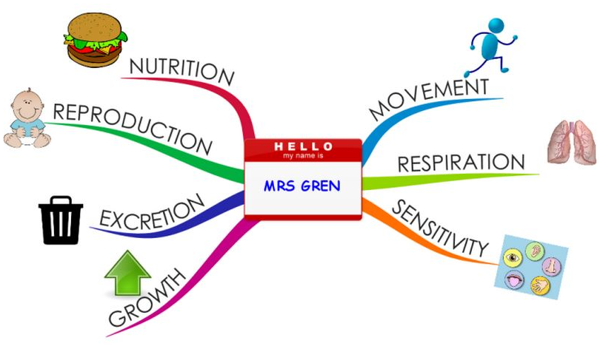

What should I already know?