
Year: 4 Strand: Biology
Topic: Animals Including Humans
Waterloo Primary School – Science Knowledge Organiser
The simple function and basic parts of the digestive system. How to explain the digestive system to a friend.
The different types of human teeth and their functions.
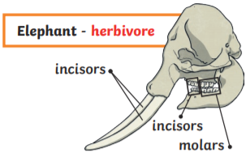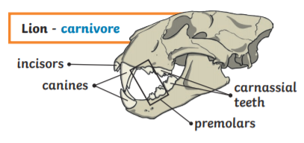

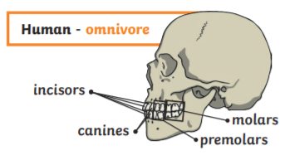
How to describe and explain food chains using scientific vocabulary. Construct simple food chains.
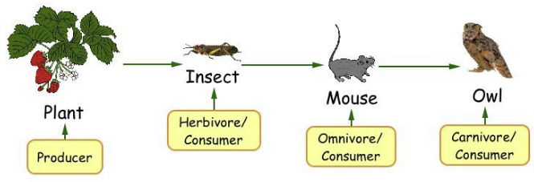

Investigate
- Recording findings using simple scientific language, drawings, labelled diagrams and keys

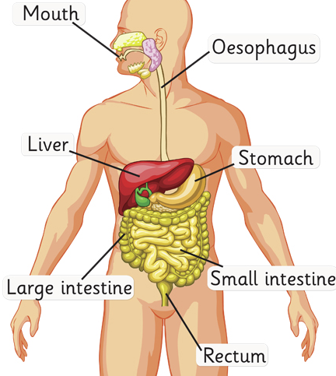
- Producer – a living thing that makes its own food
- Consumer – a living thing that eats another living thing
- Perdator – hunts and kills its food
- Prey – is hunted/killed for food
- Carnivore – eats meat
- Herbivore – eats plants
- Omnivore – eats both
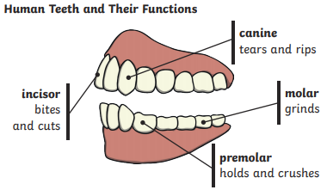

Vocabulary
- Animals that are carnivores, herbivores and omnivores
- That animals, including humans, have offspring which grow into adults
- The basic needs of animals, including humans, for survival (water, food and air)
- The importance for humans of exercise, eating the right amounts of different types of food, and hygiene.

What will I know by the end of this unit of work?
What should I already know?

