

Year: 4 Strand: Chemistry

Topic: States of Matter

Waterloo Primary School – Science Knowledge Organiser

Set up simple practical enquiries, comparative and fair tests

Make systematic and careful observations and take accurate measurements using thermometers.

Investigate

* Describe properties of solids, liquids and gases.
* That matter is made up of particles.

Solid Liquid Gas

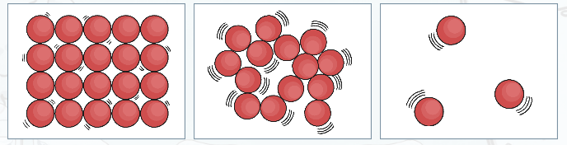

* I can group materials into solids, liquids and gases.
* That materials can change state when heated or cooled.

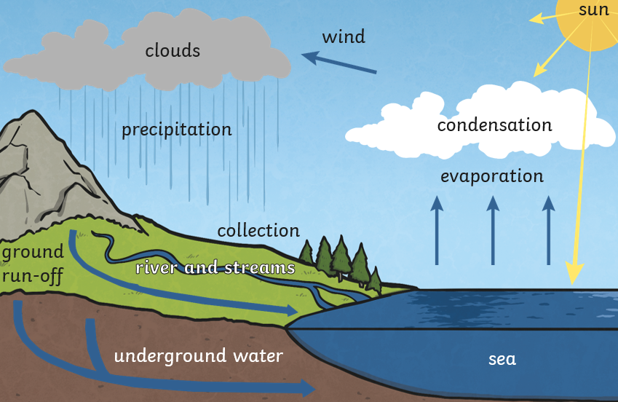

Water freezes at 0 degrees celsius.

Water boils at 100 degrees celsius.

State of matter – solid, liquid or gas

Solid – a material that kees its shape unless force is applied

Liquid – a material that will take the shape of a container. It can flow/be poured

Gas – a material which can spread out freely

Melt – when a heated material changes from a solid to a liquid.

Freeze – when a cooled material changes from a liquid to a solid

Evaporate – when a heated material changes from a liquid to a gas

Water vapour – this is water that becomes gas

Condense – when a cooled material changes from a gas to a liquid

Precipitation – Liquid or solid particles that fall from clouds (rain, sleet, hail, snow)

Vocabulary

* Different objects are made of different materials
* Materials are suitable for different purposes because of their properties (strong, flexible, waterproof…)
* We can change the shape of some solids by applying force (pushing, pulling)

What will I know by the end of this unit of work?

What should I already know?