

Year: 5 Strand: Chemistry

Topic: Materials

Waterloo Primary School – Science Knowledge Organiser

Investigate

* Plan scientific enquiries to answer questions
* Recognise and control variables
* Use fair testing
* Use test results to explain findings and to make further predictions
* Record data in tables and using labelled diagrams

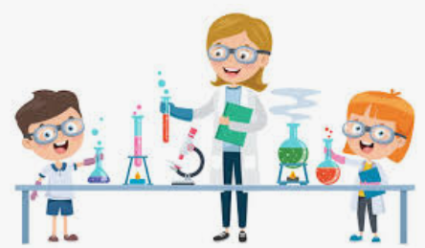

* How to group materials according to their properties (*conductivity, flexibility, hardness, insulators, magnetism, solubility, transparency*) and explain why certain materials are fit for certain purposes.
* That some materials will dissolve.
* That when materials are mixed, changes can occur.
* How to reverse some changes and how to separate some mixtures using appropriate methods and equipment.
* Burning is an irreversible change
* Sugar is soluble.
* Sand is insoluble.

Vocabulary

Melting – the process of heating a solid until it changes to a liquid

Freezing – when a liquid cools and turns to a solid

Evaporating – when a liquid turns into a gas or vapour

Condensing – when a gas, such as water vapour, cools and turns to a liquid

Reversible changes – changes which can be undone by:

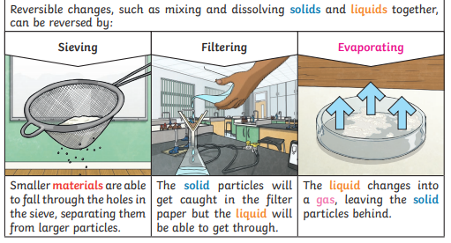

Irreversible change – changes which cannot be undone

Dissolving – when solid particles mix with liquid particles to form a solution

Soluble – can be dissolved

* There are 3 states of matter: 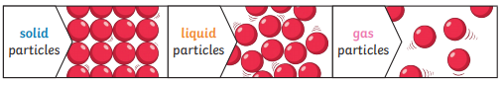
* Solid particles are close together and hold their shape
* Liquid particles can flow and take the shape of a container
* Gasses are free to move around
* Some material are conductors of electricity and some are insulators
* Some materials are transparent, some are translucent and some are opaque
* Some materials are magnetic

What should I already know?

What will I know by the end of this unit of work?