

Topic: Animals including humans. Taught alongside PSHE ‘Changing Me’

Year: 5 Biology

Waterloo Primary School – Science Knowledge Organiser

Fertilisation – the process of the male and female sex cells fusing together

Prenatal – the stage of development from fertilisation to birth

Gestation period – the length of time a femal is pregnant

Reproduction – to produce young

Asexual reproduction – a process where one parent produces new life

Sexual reproduction – a process where 2 parents – one male, one female – produce a new life

Adolescence – the social and emotional changes between childhood and adulthood

Puberty – the physical stage of changing from childhood to adulthood

Vocabulary

* Names of male and female body parts
* He menstrual cyle prepares females for making babies
* Our bodies change as we go through puberty
* A life cycle is the series of changes a livig through through, including reproduction

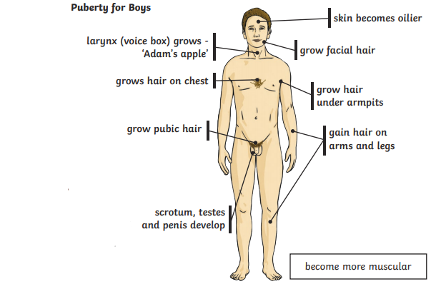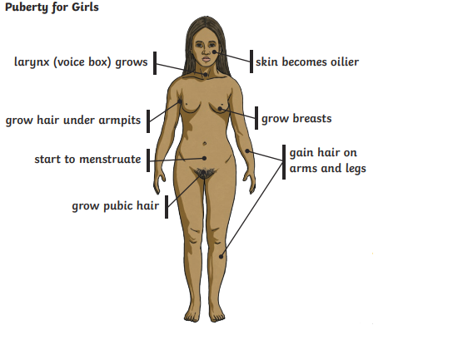

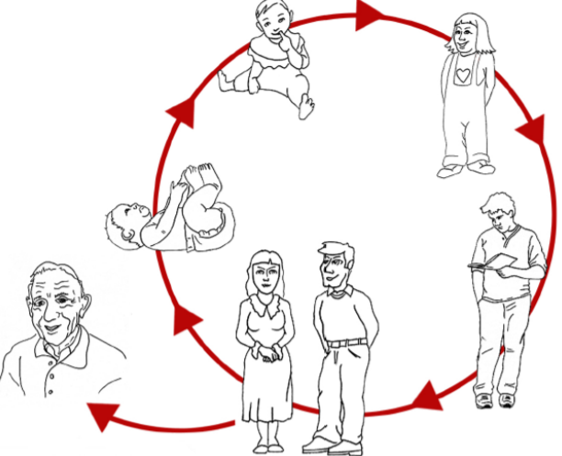

What will I know by the end of this unit of work?

What should I already know?