
Topic: Living things and their habitats taught alongside PSHE ‘Changing Me’

Year: 5 Biology
Waterloo Primary School – Science Knowledge Organiser
Reproduction is part of a life cycle. Some living things reproduce sexually.
Sexual reproduction is a form of reproduction in which genetic material from two individuals of opposite sexes mixes to create offspring.
It involves the fusion of male and female sex cells in a process called fertilisation. This is part of our life cycle.

Humans develop inside their mothers and are dependent for many years.

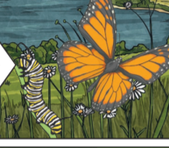 | 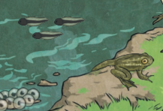

Amphibians are laid in eggs, once hatched, they go through many changes to become adults.

Birds are hatched from eggs and are then looked after by their parents.

Most plants contain both male and female parts

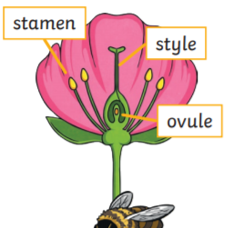

Present information using scientific diagrams

Investigate
Mammal - a warm-blooded animal with a backbone that feeds its young with milk produced by the mother and has skin usually more or less covered with hair

Amphibian – an animal that spends part of its life cycle in water and part of its life cycle on land.

Sexual Reproduction - when an egg cell from a female and a sperm cell from a male unite and develop to form a baby.

Germination - is the phase of plant growth when the seed begins to sprout.

Seed dispersal - is the way seeds get from the parent plant to a new place.

Seed formation - The making of the seed completes the process of reproduction in plants (started with the development of flowers and pollination)

Vocabulary
Life cycle - a series of stages a living thing goes through during its life

What will I know by the end of this unit of work?
What should I already know?

