
Year: 6 Biology
Topic: Living things and their habitats
Waterloo Primary School – Science Knowledge Organiser
We can categorise living things in many different ways.

How to use scientific knowledge and research to justify and explain different categorisations

Microorganisms
Are tiny living things. They
are not visible to the naked eye
so a microscope is needed to see them.
Microorganisms are found all around us. They can live in our bodies, in water, in the air and on the objects around us.

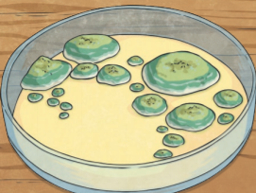

In 1735, Swedish Scientist Carl Linnaeus first published a system for classifying all living things. An adapted version of this system is still used today: The Linnaeus System.
What will I know by the end of this unit of work?
Living things can be grouped in different ways
How to use simple classification keys

What should I already know?
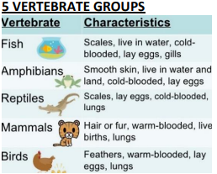
Vertebrate – animals which have a backbone/spine

Invertebrate – animals which do not have a backbone/spine

Classification – grouping living things by looking at similarities and differences

Microorganism – A microscopic organism, especially bacteria, virus or fungus.

Taxonomy – the part of science focused on classification.

Virus – a small infectious agent that multiples within the living cells of a host.

Fungi – a classification or group of living things. They are not plants, animals or bacteria.

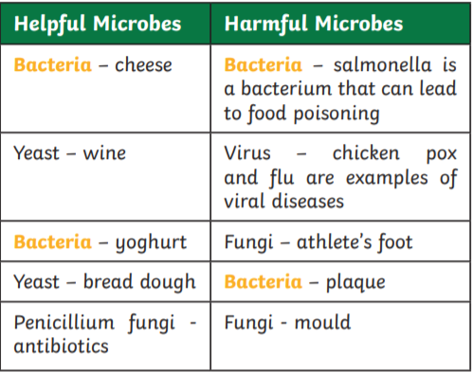
Record data using scientific diagrams and labels, classification keys and tables.
Investigate
Vocabulary

