
Year: 6
Topic: Evolution and Inheritance
Waterloo Primary School – Science Knowledge Organiser
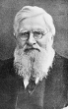
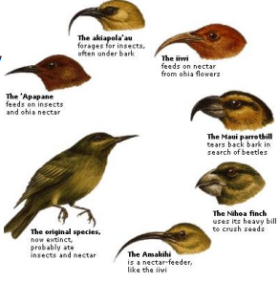
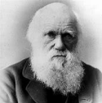
EVOLUTION BY NATURAL SELECTION
The theory of evolution by
natural selection was proposed
by Charles Darwin. Organisms
within a species
show a wide range of variation, due to their genes (inherited by their parents) and their environment.
Natural selection occurs through the following steps:
• Individuals within a species show a genetic variation.
• The individuals with the characteristics that means they are better adapted to their environment will survive
• These useful genes are passed onto the next generation. This process occurs over a large number of generations.
DARWIN’S FINCHES ADAPTATION
Darwin’s finches are
an excellent example
of the way in which
species’ gene pools
adapt for long term
survival.
Their beaks have
evolved over time to
be best suited to
obtaining food.

ALFRED WALLACE – co-published the
theory of evolution by natural
selection with Charles Darwin. He travelled the world and studied
plants and animals. His ideas
were very important in developing
how we think about nature today.

INHERITANCE - Are you ever told that you look like your parents? This is because we inherit features and characteristics from them e.g. our natural hair and eye colour, our height or the shape of our face.

Fossils – preserved remains of a living thing from the past Adaptation – the process of change so that an organism or species can become better suited to their environment
Environment – the surroundings or conditions in which a person, animal or plant lives
Evolution – the process by which different kinds of living organisms are believed to have developed from earlier forms during the history of the Earth
Inherit – to gain a quality, characteristic of predisposition genetically from a parent or ancestor
Ancestor – a person from who one is descended
Offspring - a person’s/animal’s child or children
Breeding – the mating and production of offspring by animals
Vocabulary
Fossils are the remains of prehistoric life. They are usually formed when a living thing (plant or animal) dies and the body is covered up or buried by sediment over tens of thousands of years.

What will I know by the end of this unit of work?
What should I already know?
Investigate
identifying scientific evidence that has been used to support or refute ideas or arguments.

