

Year: 5 Strand: Physics

Waterloo Primary School – Science Knowledge Organiser

Topic: Forces

* Plan scientific enquiries to answer questions
* Recognise and control variables
* Take accurate measurements
* Record data using scientific diagrams, bar and line graphs
* Use results to make predictions and set up further comparative fair tests
* Discuss the reliability of findings

Investigate

* Usupported objects fall because of gravity
* How to explain the effects of friction, air resitance and water resistance and friction on moving objects
* Mechanisms can increase or reduce friction:

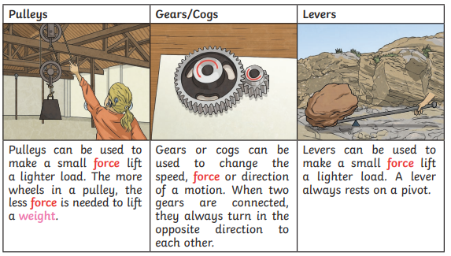

Earth’s gravitation pull – the pull that Earth exerts on an object, pulling it towards its centre.

Weight – the measure of the force of gravity

Mass – measure of how much matter is inside an object

Friction – A force that acts between two surfaces or objects that are moving, or trying to move across each other

Air resistance – a type of friction caused by air pushing against a moving object

Water resistence – a type of friction caused by water pushing against a oving object

Buoyancy – An upward thrust (force) that a liquid applies to an object

Streamlined – when an object is shaped to minimise frictions

Mechanism – parts which work together in a machine (pulleys, gears, levers)

Vocabulary

* Forces are pushes or pulls that can make an object: start to move, stop moving, change direction, change speed, change shape
* Gravity is a pull force

What will I know by the end of this unit of work?

What should I already know?