Y6 Data – 2025
National Context
74% - Reading
72% - GPS
73% - Maths
72% - Writing
81% - Science
All Pupils
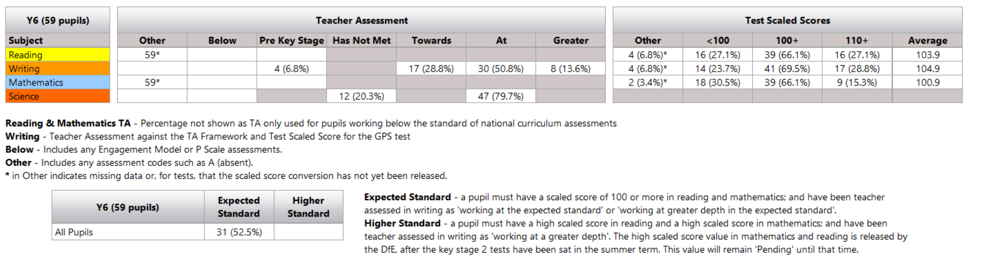
Excluding EHCPs in Unit Provision and one EHCP from mainstream going to a specialist Secondary
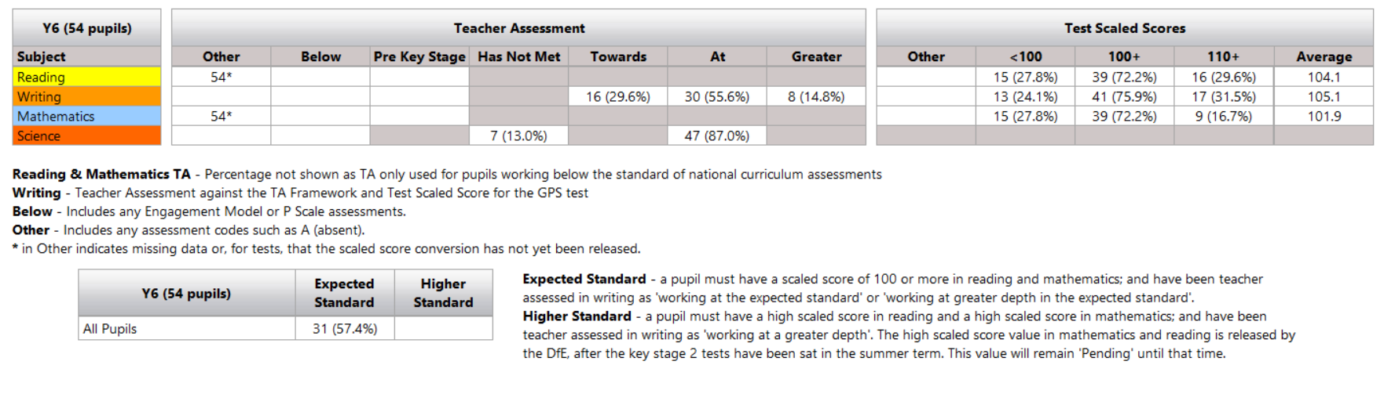
Excluding EHCPs for Cognition and Learning


