​​​​​​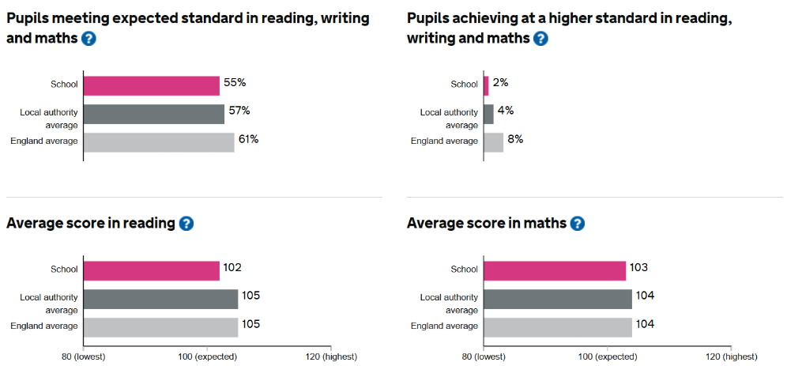

This includes children with EHC plans in our Specialist Autism and Cognition & Learning Units.

